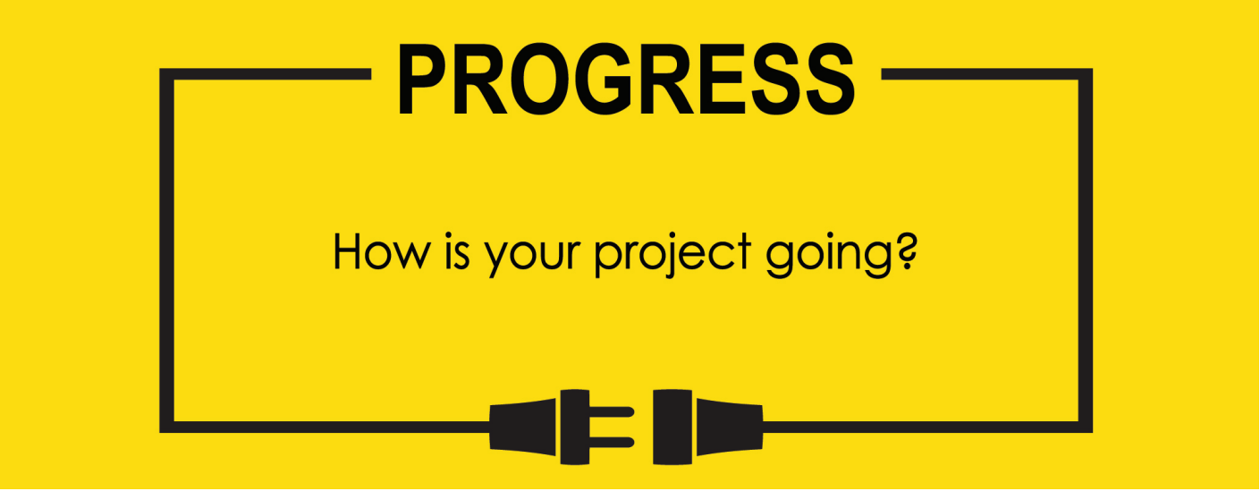

**Name: Zach Wilcox**

**Project Title: GreenBox**

**Previous Goals**

What were your three goals from last week? Were you able to complete them? If so, select Completed. If not, select the level of completion and explain in the Notes section why the goal was not completed, what still remains to be done, and when you expect to finish work on the goal.

Goal #1 from last week: Finish box build

**Status:** _____Completed _____Partially Completed __x___No Progress

**Notes:**

Focus was on software this week around and short time allowed only for a little bit of work.

Goal #2 Finish GPIO output code

**Status:** _____Completed __x___Partially Completed _____No Progress

**Notes:**

Some progress was made on the code and it compiles without errors or warnings, but due to being on the road I was not able to live test it using the MCU and thus can’t fully know if it functions as intended or not.

Goal #3 Test I/O for sensor to system control

**Status:** _____Completed _____Partially Completed __x___No Progress

**Notes:**

Due to not finishing the output code the entire I/O system could not be tested.

**Next Three Goals**

Choose three subtasks from your Gantt chart and use them to form goals that you plan to complete this week. In the text box beneath each goal, give details about what you plan to accomplish. Include details such as what materials are needed, how many hours each day you plan to devote to the task, and so on.

NOTE: THESE ARE INDIVIDUAL GOALS THAT YOU PLAN TO ACCOMPLISH. THESE ARE NOT TEAM GOALS.

**Goal #1:** Finish box build

**Goal #2:** Finish input/output software

**Goal #3:** Test input/output software

Very little has changed in the last week due to a school event attended for the majority of the week, so some software was updated, but not fully tested as the physical hardware is needed for that step of the process.

Gantt Chart has not changed

